Kingston Data Traveler Exodia M USB Flash Drive 64GB USB 3.2 |DTXM/64GB (CZONE)
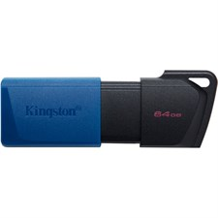
Key Features
- 64GB Storage Capacity: With 64GB of storage, the Data Traveler Exodia M offers a good balance between cost and capacity, making it an ideal option for storing documents, photos, videos, music, and backups.
- USB 3.2 Performance: Supporting USB 3.2 Gen 1 (backward compatible with USB 2.0), the Exodia M delivers fast transfer speeds, up to 100MB/s for reading data, making it faster than older USB 2.0 drives for transferring large files.
- Easy to Use: The drive is plug-and-play, requiring no software or drivers to be installed. Simply plug it into a USB-A port on a compatible device, and it’s ready for use.
Software and Compatibility
- Wide OS Compatibility: The Data Traveler Exodia M is compatible with Windows, macOS, and Linux systems, as well as other devices with USB-A ports. It supports both exFAT and FAT32 file systems, providing cross-platform compatibility.
Warranty and Support
- 5-Year Limited Warranty: Kingston offers a 5-year limited warranty on the Exodia M, ensuring the drive’s reliability and providing peace of mind for users who depend on it for storing important data.
- Kingston Customer Support: Kingston provides robust customer support, including product documentation, technical assistance, and troubleshooting resources through their website.

